ME 421 Final Project: 3D-Printed Smart Filter, By Ian Sanabia
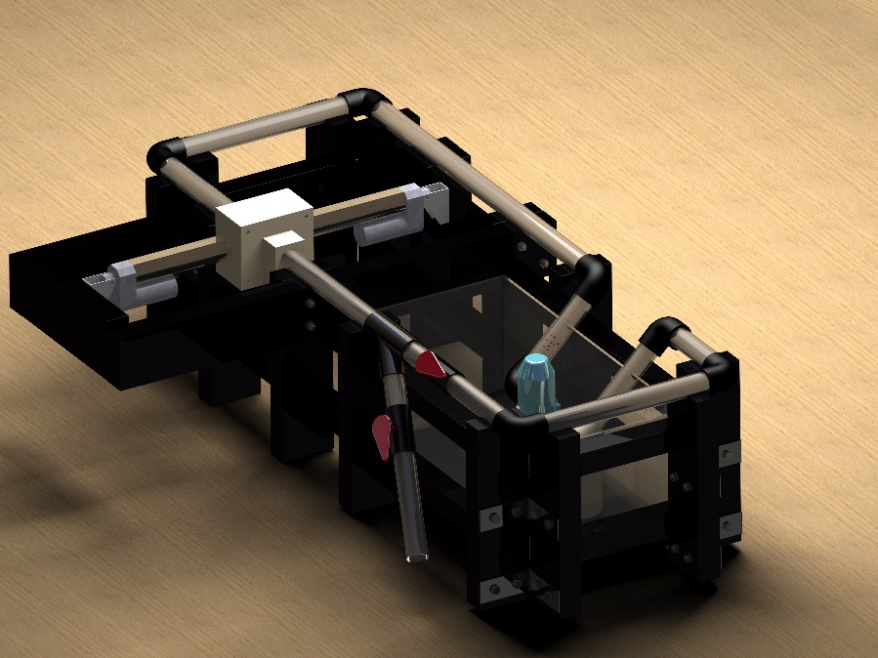
The 3D-Printed smart filter was designed by the Particle Busters to create a hands-free filter that can be flushed by applying a force on the horizontal axis of the filter using linear actuators. To create this project, I created the black skeleton with simple geometry and the mirror tool. Then, I added the 1” Nom pipe in different lengths to create the piping system shown, and imported the 90 degree elbows, nuts, and bolts from McMaster Carr.
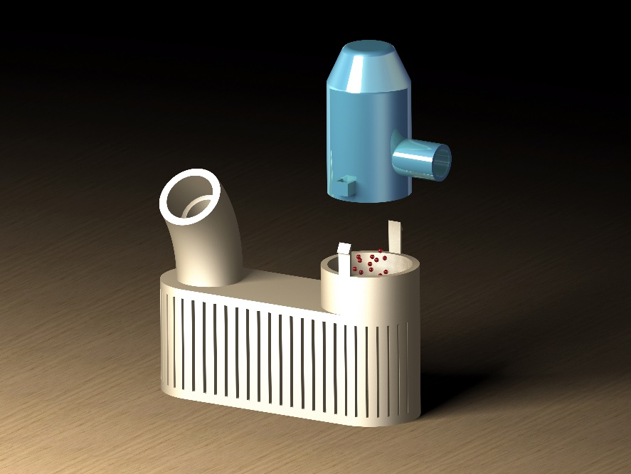
While creating the renderings shown, I found that the spherical light source worked the best. Directional light was more difficult to perfect and orient, whereas a spherical light source can be positioned to get beautiful angles with an even light distribution. You can then increase the intensity of the light to create an extremely realistic environment. The environment was textiled with cedar, and oriented to flow with the direction of the assembly. For the rendering settings, I raised the image size and overall quality to its maximum and increased the amount of reflections for the render itself. That means that each of these renderings took about 2 hours. I also adjusted the material properties to obtain the appropriate amount of reflectivity for each part. The rendering capabilities of CATIA are indisputably outstanding. Below are more images of the project. I hope you enjoy!

